|  |  |
| --- | --- |
| Author Name : | Zhonglong Chen  Meiq Lin |
| Author Email : | [zhonglong.chen@tpv-tech.com](mailto:zhonglong.chen@tpv-tech.com);  [meiq.lin@tpv-tech.com](mailto:meiq.lin@tpv-tech.com) |

2k15 Android HTV develop design

Virgin Mode

**DOCUMENT REFERENCE FRAME**

Reference Number :

Version : 01

Status : Release

Date : 20/08/2015 15:21

**Table of Contents**

1. Introduction 3

1.1 Purpose and Scope 3

1.2 Target Audience 3

1.3 Terminology 3

1.4 References 3

2. Requirement 4

2.1 Instant Initial Cloning 4

2.2 Manual Virgin Installation 4

2.2.1 Language 4

2.2.2 Country 4

2.2.3 Time zone 4

2.2.4 Picture mode setting 5

2.2.5 Professional Mode 5

2.2.6 Room ID 5

2.2.7 Virgin Mode Finish screen 5

3. Design 6

3.1 Architecture 6

3.1.1 Component 6

3.1.2 Procedure 7

3.1.3 Dependence 9

3.2 Class introduction 9

3.2.1 Activity extended class 11

3.2.2 ListLoaderDataScreen extended class 12

3.2.3 PinEntryDataScreen extended class 12

3.3 Interface description 12

3.3.1 Intent interface 12

3.3.2 ASTA interface 13

4. Revision History 14

# Introduction

## Purpose and Scope

* Precise understanding of the task by owner
* Team leader review both the spec and code that upload to HTV branch.
* Project control method
* In case people transfer
* Improve the quality of the code

## Target Audience

This document is intended for the roles/groups/teams as below:

* Software Architects (product, subsystem, integration)
* Software Designers and Developers (who shall implement these features)
* Subsystem Test Designers (who shall test these features)

## Terminology

|  |  |
| --- | --- |
| **Terms** | **Details / Explanation** |
| HTV | Hospitality Television |
| CTV | Consumer Television |
| IIC | Instance Initial Cloning |
| RC | Remote Control |
|  |  |
|  |  |
|  |  |

## References

|  |  |  |  |
| --- | --- | --- | --- |
| **Reference ID** | **Reference Name** | **Reference Version** | **Link to Reference** |
| 01 | 2k15_TPV_HTV_Android_FRS.docx | V3.0 |  |
|  |  |  |  |
|  |  |  |  |
|  |  |  |  |
|  |  |  |  |

# Requirement

Installation of settings in Virgin Mode is a feature which will establish the first ever configuration of the TV from out of factory settings. Thus this constitutes the initial configuration before the TV could be used.

Virgin mode settings can be done through IIC or by manual Virgin Mode configuration via a wizard.

## Instant Initial Cloning

Instant initial cloning enables to clone a large number of TVs out of the box (Virgin Mode). This is achieved by cloning via USB or IP or RF.

This reduces number of steps to clone TVs and also reduces the manual intervention as much as possible. If chosen Instant Initial Cloning via IP or RF, manually intervention can be further reduced by avoiding the insertion of USB to each TV set.

When TV wakes up in Virgin Mode, TV shall try to do Upgrade/cloning via USB or IP or from RF.

Thus Upgrade and Cloning for Instant Initial Cloning in all the modes shall happen in the TV’s on state.

Once IIC is triggered it shall complete Upgrade and cloning without any manual intervention from the user if valid Clone Items are available.

Search for clone items shall be done in parallel on all the Clone-Mediums namely USB, IP and RF.

If Clone Items are found in any of the Clone-Mediums, TV shall cancel the Clone-Item scan on rest of the mediums and shall proceed with cloning on the medium on which Clone Items have been found.

If Cloning is successful on the selected medium, TV shall reset the virgin mode, and go to the “WC_Fast” as indicated “Startup Sequence”. Please refer to the startup sequence section for details on the execution flow when the IIC execution is ended.

A status screen showing progress indicator shall be displayed during the cloning process.

This screen shall show the download and upgrade progress for all 3 cloning methods: USB, RF and IP.

These status/progress screens shall be same as defined in Cloning and Upgrade section for each of the respective cloning mediums.

Instant Initial Cloning shall not depend on any settings including the Professional Settings menu “Clone/Upgrade → Upgrade Mode” menu item.

If user clicks skip/close, IIC screen shall be removed and TV continues to with Virgin Installation. This shall be applicable depending various factors as described in “Cloning and Upgrade” section

As a special condition for IIC, even one clone item out of a set of Clone Items is successfully cloned on to the TV, then IIC shall be as Successful, and TV shall not go back to Virgin mode.

## Manual Virgin Installation

### Language

Language Selection screen shall follow the same as in CTV Virgin Installation. But the Language list shall contain the HTV specific language list as stated in UIO.

### Country

Country list shall be as mentioned in the “UIO TIME ZONE COUNTRY LIST” list.

Only the countries that are listed and applicable in the “TIME ZONE COUNTRY LIST” of the UIO shall be listed in the screen.

### Time zone

Time zone list shall be as mentioned in the UIO TIME ZONE COUNTRY LIST.

Only the time zones that are applicable for the listed country as mentioned in the “TIME ZONE COUNTRY LIST” shall be shown in the screen.

### Picture mode setting

The screen shall be able to select the Picture mode as standard or natural. The default selection should be standard.

### Professional Mode

The screen shall be able to select the Professional mode as On or Off during Virgin installation. Professional Mode cannot be set as ON by default due to Factory Mode testing support.

### Room ID

TV shall also allow to enter the Room ID during Virgin Installation.

Room ID entry is completed by keying-in numeric using the remote control (Digit Entry) and pressing “Ok” key to confirm.

Room ID consists of 5 Digits and in case, the user enters room ID that is less than 5digits long, “0”s shall be prefixed to the entered number.

By default, TV shall display the default Room ID which is “00000”. As the user inputs numeric values, 0s from the right (to left) shall be sequentially replaced with the value that is input by the user.

No Onscreen Keyboard shall be shown when this screen is displayed. Entry shall be limited to only numeric values.

### Virgin Mode Finish screen

After successful entry of room ID following “Finish” screen shall be shown.

The virgin installation sequence shall not be interruptible by the following user and system events:

* Any RC command that results in a direct state transition (e.g. RC Exit, RC Watch TV, RC EPG, RC Teletext, RC Smart TV ..)
* Any system event that results in a direct state transition (e.g. USB break-in, HDMI break-in, DLNA break-in, SCART break-in ...)
* Note: This is applicable for the entire virgin install sequence - including the individual wizards (T/C installation, Settings assistant, network wizard, add device wizard) and the main virgin wizard screens - till the Finish Virgin screen.
* In case of break-way IIC flow, interruptions in IIC mode shall fall back to the normal Virgin mode flow as detailed above.
* Refer to EAT for the complete list.

Refer to Chapter 37 Virgin Mode (Installation) in FRS document for details.

# Design

## Architecture

### Component

Virgin Mode contains five components, as IICActivity, LanguageSettingActivity, CountrySettingsActivity, HtvSpecialSettingsActivity and VirginFinishActivity.

The figure below shows the relationship of each component which is described in black bordered rectangle, and implemented by Activity. The CountrySettingsActivity and VirginFinishActivity in blue mean to reuse CTV component; others in green mean to be new added. The detail screen is described in gray bordered rectangle, and implemented by ListLoaderDataScreen or PinEntryDataScreen which are TPVision widget.

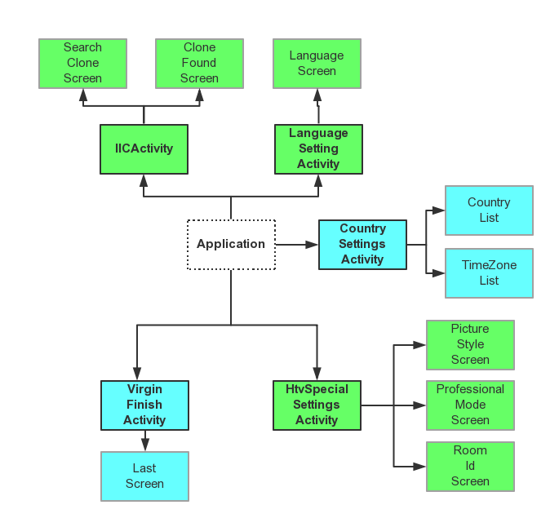

Figure 1 Virgin Mode application components

The function for each component is:

1. IICActivity: for Instance Initial Cloning feature, divide to SearchCloneScreen for searching clone item and CloneFoundScreen for search result;
2. LanguageSettingActivity: for selecting language, only contains LanguageScreen;
3. CountrySettingsActivity: for selecting Country and Time zone, divide to CountryList for selecting country and TimeZoneList for selecting time zone, note that only some country support multiple time zone;
4. HtvSpecialSettingsActivity: for HTV special feature, divide to PictureStyleScreen for selecting picture mode, ProfessionalModeScreen for selecting professional mode and RoomIdScreen for setting room id;
5. VirginFinishActivity: for system property, only contain LastScreen;

### Procedure

Virgin Mode contains Instance IIC Selection, Country and Time zone Selection, Picture Style, Professional Mode and Room ID settings. The application wizard will guide user to go through each screen and make choice in sequence. Each screen could not be skipped except IIC screen.

The figure below shows the application procedure and IIC procedure.

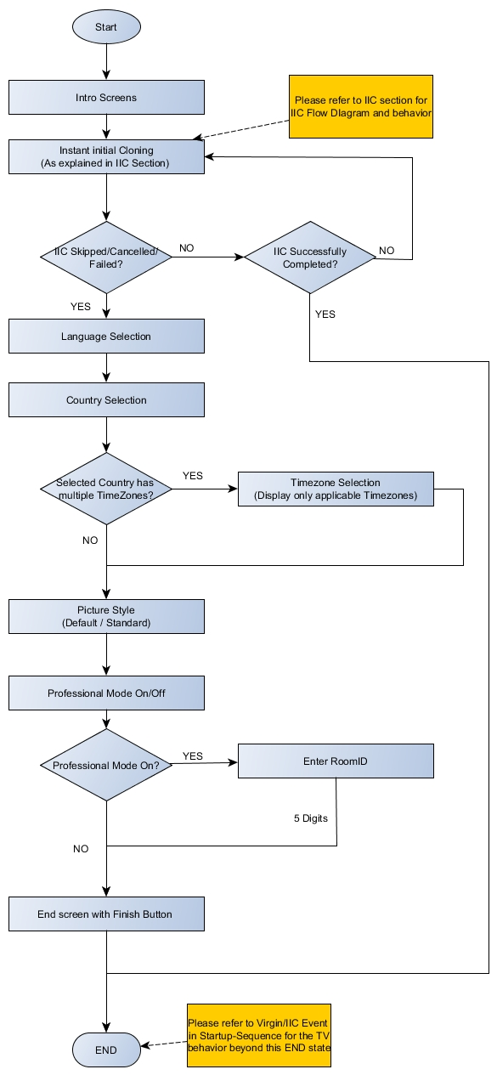

Figure 2 Virgin Mode application procedures



Figure 3 IIC procedure

HTV Virgin Mode will reuse CTV Virgin Mode source code composition in whole and make some modification according to HTV requirement.

1. Retain Country Screen, Time zone Screen and Finish Screen in CTV Virgin Mode;
2. Rewrite Language Screen and discard Google GMS Setting;
3. Add IIC Screen, Picture Style Screen, Professional Mode Screen and Room ID Screen;

The figure below shows the difference between HTV Virgin Mode and CTV Virgin Mode.

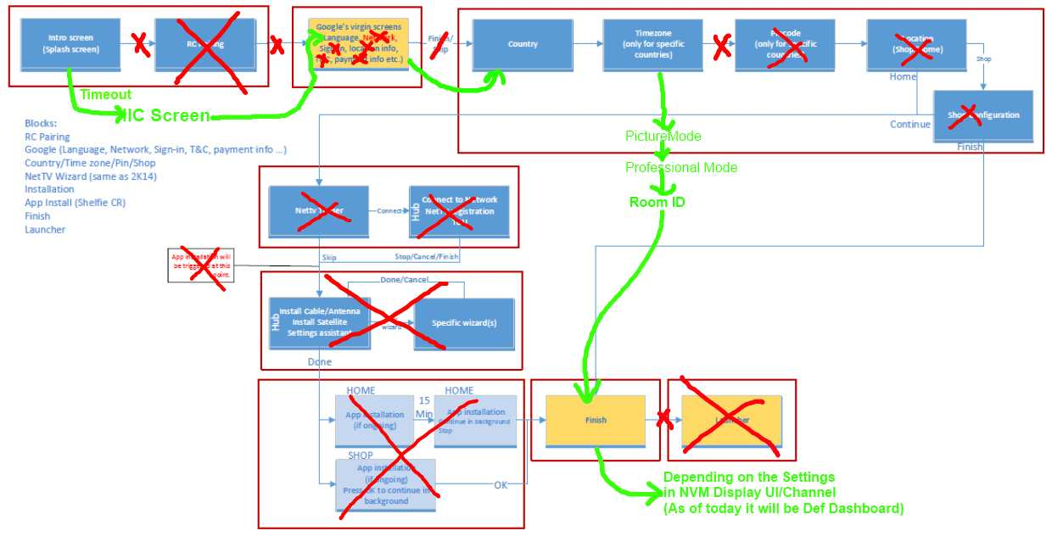

Figure 4 Differences between HTV Virgin Mode and CTV Virgin Mode

### Dependence

Virgin Mode base on ASTA architecture and ASTA provide jar as:

1. tvfw / tvjar: provide interface for TV setting;
2. tvwidgets2k15 / uifw / uijar: extended UI widget by TPVision, compose base Android UI widget to customized UI widget and easy to use; for example, Virgin Mode only use PageWizard widget to implement the UI layout;
3. tvvi_res_2k15: resource library, such as layout file, drawable, style, dimension and so on, make UI asset independent of application. This will get two benefits, first reduce application size, and second make style of each application similar;
4. tvstrings: multiple language string table, contains 39 kinds of language, and easy to translate at one time;

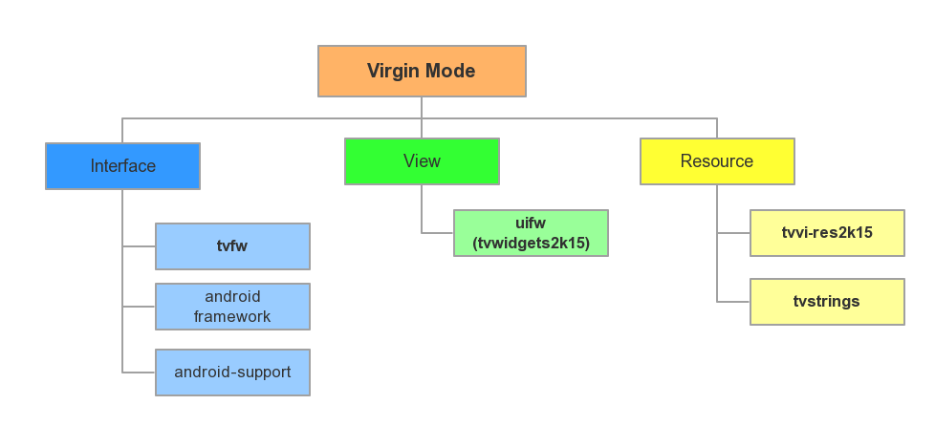

Figure 5 Dependence in Virgin Mode

## Class introduction

The table below shows the primary package in Virgin Mode.

|  |  |  |
| --- | --- | --- |
| **Package** | **Class** | **Description** |
| org.droidtv.devicesetup | HomeActivity  IICActivity  LanguageSettingActivity  CountrySettingsActivity  HtvSpecialSettingsActivity  VirginFinishActivity | Activity component |
| org.droidtv.devicesetup.screens | CountryList  TimeZoneList  VirginInstallationConstants  LastScreen  IDeviceSetupController | CTV screen and interface |
| org.droidtv.devicesetup.htv | SearchCloneScreen  CloneFoundScreen  LanguageScreen  PictureStyleScreen  ProfessionalModeScreen  RoomIdScreen | HTV special screen |
| org.droidtv.devicesetup.util | ActivityManagerUtil  PackageManagerUtil | Utility |

The table below shows the primary classes and their functions.

|  |  |  |
| --- | --- | --- |
| **Class Name** | **Type** | **Description** |
| HomeActivity | Activity | Application preload entry, to disable system key in Virgin Mode |
| IICActivity | Activity | Application primary entry |
| SearchCloneScreen | ListLoaderDataScreen | IIC searching clone screen, to scan available clone item via USB, IP and RF in parallel |
| CloneFoundScreen | ListLoaderDataScreen | IIC clone found screen, to launch clone process activity |
| LanguageSettingActivity | Activity |  |
| LanguageScreen | ListLoaderDataScreen | Select language screen |
| CountrySettingsActivity | Activity |  |
| CountryList | ListLoaderDataScreen | Select country screen, check if current country support multiple time zone and go next |
| TimeZoneList | ListLoaderDataScreen | Select time zone screen |
| HtvSpecialSettingsActivity | Activity |  |
| PictureStyleScreen | ListLoaderDataScreen | Select picture style screen |
| ProfessionalModeScreen | ListLoaderDataScreen | Select professional mode screen, check if professional mode is on and go next |
| RoomIdScreen | PinEntryDataScreen | Set room id screen |
| VirginFinishActivity | Activity |  |
| LastScreen | ListLoaderDataScreen | Finish screen, to enable system key |
| IDeviceSetupController | Interface | Wizard screen interface, to handle back key |
| ActivityManagerUtil | Class | Activity utility, to launch or finish specified activity |
| PackageManagerUtil | Class | Package utility, to enable or disable specified activity |
| VirginInstallationConstants | Class | Constants for country and time zone |

Each wizard screen in Virgin Mode is similar in UI layout and user experience, and the related code is similar too. Here is the description of variable and method in each class, group by its type (base class).

The figure below shows the class relationship.

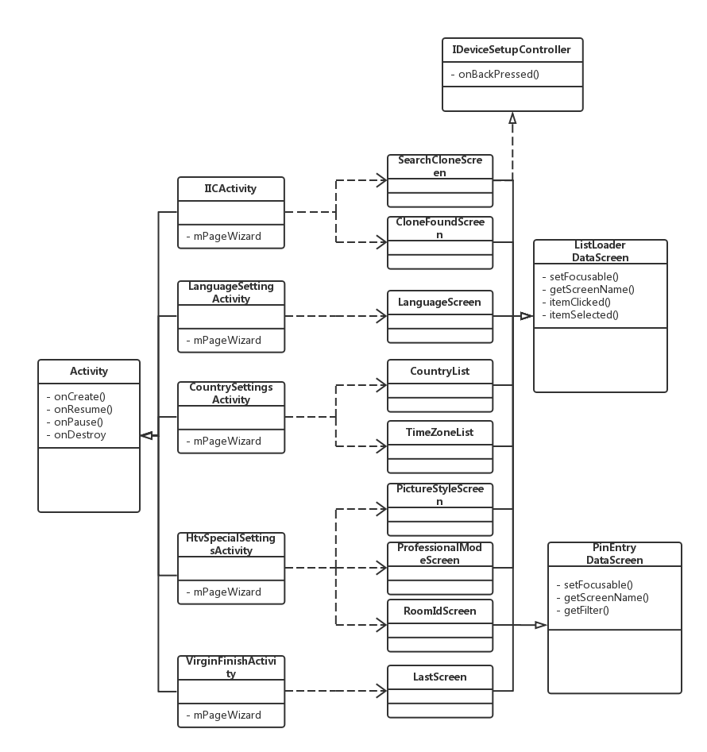

Figure 6 Class Diagram

### Activity extended class

**Example**

IICActivity, LanguageSettingActivity, CountrySettingsActivity, HtvSpecialSettingsActivity and VirginFinishActivity

**Variable**

1. mPageWizard: PageWizard, view in each screen
2. mManger: PageWizardScreenManager, to load wizard screen and switch between each screen;

**Method**

1. onCreate: apply TPVision customized theme, call setContentView to load layout file, each activity uses the same layout file;
2. onResume: initialize mPageWizard and mManger, call setPageWizardSteps in PageWizardScreenManager to load wizard screen;
3. onBackPressed: block back key and redeliver to each screen;

### ListLoaderDataScreen extended class

**Example**

SearchCloneScreen, CloneFoundScreen, LanguageScreen, CountryList, TimeZoneList, PictureStyleScreen, ProfessionalModeScreen and LastScreen

**Method**

1. <Constructor>: set title and description text in left, and initialize actionView in right by string array;
2. setFocusable: callback when got or lost focus, to check if screen is visible and set focus to specified widget;
3. getScreenName: return class name;
4. itemClicked: callback when list item clicked, to take effect of setting item and switch to next screen or other activity;
5. itemSelected: callback when list item selected, ignore now;
6. onBackKeyPressed: callback when back key pressed, to go back to previous screen or activity;

### PinEntryDataScreen extended class

Such as: RoomIdScreen

**Method**

1. <Constructor>: set title and description text in left, and initialize EditText in right;
2. setFocusable: callback when got or lost focus, to check if screen is visible and set focus to specified widget;
3. getScreenName: return class name;
4. getFilter: ignore now;
5. onBackKeyPressed: callback when back key pressed, to go back to previous screen or activity;

## Interface description

### Intent interface

IIC use broadcast to communicate with USB/IP/RF service; it sends broadcast to start or stop searching clone item and receive the result.

The table below shows the broadcast intent in USB clone.

|  |  |  |  |  |
| --- | --- | --- | --- | --- |
| **Action** | **Send** | **Receive** | **Intent Action** | **Intent Extra** |
| Start USB search | IIC | Pbs server | org.droidtv.intent.action.IIC.USB_SEARCH_START | N/A |
| Stop USB search | IIC | Pbs server | org.droidtv.intent.action.IIC.USB_SEARCH_STOP | N/A |
| Search result | Pbs server | IIC | org.droidtv.intent.action.IIC.USB_SEARCH_RESULT | ("FW", "exists") ("FW", "not_valid") ("FW", "not_exist")  ("cloneitem", "exists") ("cloneitem", "not_exist") |
| USB to TV clone |  |  | org.droidtv.intent.action.clone.USB_TO_TV | N/A |

The table below shows the broadcast intent in IP clone.

|  |  |  |  |  |
| --- | --- | --- | --- | --- |
| **Action** | **Send** | **Receive** | **Intent Action** | **Intent Extra** |
| Start IP search | IIC | IP Server | org.droidtv.intent.action.IIC.IP_SEARCH_START | N/A |
| Stop IP search | IIC | IP Server | org.droidtv.intent.action.IIC.IP_SEARCH_STOP | N/A |
| Search result | IP Server | IIC | org.droidtv.intent.action.IIC.IP_SEARCH_RESULT | ("cloneitem", "exists") ("cloneitem", "not_exist") |
| IP to TV clone |  |  | org.droidtv.intent.action.clone.IP_TO_TV | N/A |

The table below shows the broadcast intent in RF clone.

|  |  |  |  |  |
| --- | --- | --- | --- | --- |
| **Action** | **Send** | **Receive** | **Intent Action** | **Intent Extra** |
| Start RF search | IIC | RF server | org.droidtv.intent.action.RF_SEARCH_START | N/A |
| Stop RF search | IIC | RF server | org.droidtv.intent.action.RF_SEARCH_STOP | N/A |
| Search result | RF server | IIC | org.droidtv.intent.action.RF_SEARCH_RESULT | ("cloneitem", "exists") ("cloneitem", "not_exist") |
| RF to TV clone |  |  | org.droidtv.intent.action.clone.RF_TO_TV | N/A |

### ASTA interface

Virgin Mode use tvfw to control TV setting, such as ITvSettingsManager to control system setting and ITvVideoManager to control picture setting. The interface is in key-value format.

#### ITvSettingsManager

1. putInt(int key, int reserved, int value)
2. putString(int key, int reserved, String value)

The table below shows the key-value used in ITvSettingsManager.

|  |  |  |
| --- | --- | --- |
| **Feature** | **Key** | **Value** |
| Language | MENULANGUAGE | InstallationLanguageConstants.* |
| Professional Mode | PBSMGR_PROPERTY_PROFESSIONAL_MODE | PBSMGR_PROFESSIONAL_MODE_ON  PBSMGR_PROFESSIONAL_MODE_OFF |
| Room Id | PBSMGR_PROPERTY_ROOM_ID | {String} |

#### ITvVideoManager

1. setProperty(int key, int value)

The table below shows the key-value used in ITvVideoManager.

|  |  |  |
| --- | --- | --- |
| **Feature** | **Key** | **Value** |
| Picture Style | VIDMGR_PROPERTY_PICTURESTYLE | VIDMGR_PROPERTY_STYLE_STANDARD  VIDMGR_PROPERTY_STYLE_NATURAL |

# Revision History

|  |  |  |  |  |
| --- | --- | --- | --- | --- |
| **Version** | **Date** | **Status** | **Author** | **Description** |
| V0.1 | 2015-7-31 |  | Zhonglong Chen | Initial version |
| V0.2 | 2015-8-11 |  | Meiq Lin | Add intent interface |
| V1.0 | 2015-8-20 |  | Zhonglong Chen | Translate to English |
|  |  |  |  |  |